**MODULE 4 - EXECUTIVE SUMMARY REPORT**

ALY6050 - Introduction to Enterprise Analytics

Instructed by Prof. Dr. Roy Wada

Vidhya Lakshmi Vaithilingam Palanimurugan

May 09, 2022

**INTRODUCTION**

Prescriptive analytics is a process that analyzes data and provides instant recommendations on how to optimize business practices to suit multiple predicted outcomes. In essence, it takes the information we have (data), comprehensively understands that data to predict what could happen, and suggests the best steps forward based on informed simulations. A Prescriptive model is created based on prescriptive analytics. The model structures to predict outcomes and then utilizes a combination of machine learning, business rules, artificial intelligence, and algorithms to simulate various approaches to these numerous outcomes. It then suggests the best possible actions to optimize business practices. A Prescriptive Model for Strategic Decision-making is used to make real quick decisions based on the theoretical foundation of normative theory in combination with the observations of descriptive theory.

Inventory management refers to the process of ordering, storing, using, and selling a company's inventory. This includes the management of raw materials, components, and finished products, as well as the warehousing and processing of such items. Decisions regarding inventory can be placed in two general categories: (1) those decisions that affect the quantity of inventory and (2) those decisions that affect the per-unit cost of inventory. An Inventory Management Decision Model is the prescriptive decision model which helps to reduce the total cost involved in inventory management.

**PROBLEM STATEMENT**

The two important inventory decisions that managers handle is how much to order or produce for additional inventory, and when to order or produce it to reduce the overall inventory cost, which includes both the cost of retaining inventory and the cost of ordering it from the supplier. This project focuses on creating an inventory management decision model for a manufacturing company with the following data:

* Estimated annual demand is 15,000 units (assumed constant throughout the year)
* Cost of each unit is $80
* Estimated holding cost per unit is 18% of unit value
* Order cost with supplier is $220
* The company's policy is to order twice as many units when inventory levels reach a specified reorder point that offers enough stock to meet demand until the supplier's order can be dispatched and received

**CREATING AN INVENTORY MANAGEMENT DECISION MODEL**

**Defining the data and parameters**

The decision model would often involve three types of factors whose values would influence the outcome of that model. They are the model parameters, decision variables, and uncontrollable inputs. Uncontrollable inputs are factors over which the decision-maker has no influence, such as a competitor's decision or reaction. A model parameter is an internal model configuration variable whose value can be inferred using data. When making predictions, the model needs them, and their values determine the model's ability to solve the problem. In an optimization problem, decision variables are system parameters that are unknown, and the model is built to determine its value.

Table 1 lists the various parameters used for this inventory management decision model. The objective of this model is to minimize the total cost involved in managing the inventory.

*Table 1: Model variables and parameters*

|  |  |
| --- | --- |
| **Model Parameters** | Unit Cost  Annual Holding Cost  Order Cost  Annual Carrying cost |
| **Decision Variables** | Reorder-point Quantity  Order Quantity  Number of orders made annually |
| **Uncontrollable Variable** | Annual Demand (in units) |
| **Model Objective** | To minimize the Total Inventory Cost |

**Developing a mathematical model for the total inventory cost**

A mathematical model is created such that it computes the annual ordering cost and annual holding cost based on the average inventory of the product held throughout the year. It is then used to compute the total inventory cost for various scenarios. The Decision Variables for which the objective of minimum cost is extracted and solves the given problem.

The model is based on the below mathematical formulas given for calculating annual ordering cost and annual holding cost. The annual total cost involved for inventory management is the sum of these two values.

The annual ordering cost is the cost involved for ordering from the supplier times the number of orders placed for a product in the given year.

**Annual Ordering Cost** = **Order Cost** x **Number of times ordered in a year**

The annual holding cost is the product of the order quantity, cost of holding an unit for a given day, number of days the product was held in the inventory, and the number of orders placed for the product annually.

**Annual Holding Cost = 2Q * ((Unit Cost * Carrying Cost Rate)/365) * (2Q/(Annual demand/365)) * (annual demand/2Q)**

The total annual cost of the inventory is sum of the annual ordering cost and the annual holding cost of the given product.

**Total Annual Cost** = **Annual Ordering Cost** + **Annual Holding Cost**

**MODEL IMPLEMENTATION**

**One-way tabulation in Excel spreadsheet**

All the above-mentioned formulas are implemented in excel spreadsheet. A one-way tabulation is created by implementing this model. The total inventory cost involved is calculated for different values of the order quantity. The values of order quantities ranges from 200 to 2000 units and its corresponding inventory levels are 100 to 1000 units. Table 2 below shows the glimpse of various total cost values for various inventory level and order quantities.

*Table 2: One-way tabulation to calculate minimum total cost*

|  |  |  |
| --- | --- | --- |
| **Inventory Level Q** | **Order Quantity 2Q** | **Total Cost** |
| 100 | 200 | 19380 |
| 120 | 240 | 17206 |
| … | … | … |
| 200 | 400 | 14010 |
| 220 | 440 | 13836 |
| **240** | **480** | **13787** |
| 260 | 520 | 13834 |
| 280 | 560 | 13957 |
| … | … | … |
| 420 | 840 | 16025 |
| 440 | 880 | 16422 |
| 460 | 920 | 16835 |
| … | … | … |
| 700 | 1400 | 22517 |
| 720 | 1440 | 23028 |
| 740 | 1480 | 23542 |
| … | … | … |
| 960 | 1920 | 29367 |
| 980 | 1960 | 29908 |
| 1000 | 2000 | 30450 |

The figures 1 and 2 illustrates the variation of the total inventory cost (in $) for various values of the order quantity. Figure 2 zooms in find the value of the order quantity on which the total inventory cost has the minimum value. We can conclude that when the **order** **quantity is 480** there occurs the **minimum total inventory cost** of **$13787** (annual cost).

**One-way tabulation in R**

The defined mathematical model is also implemented using R programming. The figures 3 and 4 illustrates the variation of the total inventory cost (in $) for various values of the order quantity. Figure 4 zooms in find the value of the order quantity between **220 and 260 increased by 5 units**. We can see that the total inventory cost has the minimum value when the **order** **quantity is 480.**

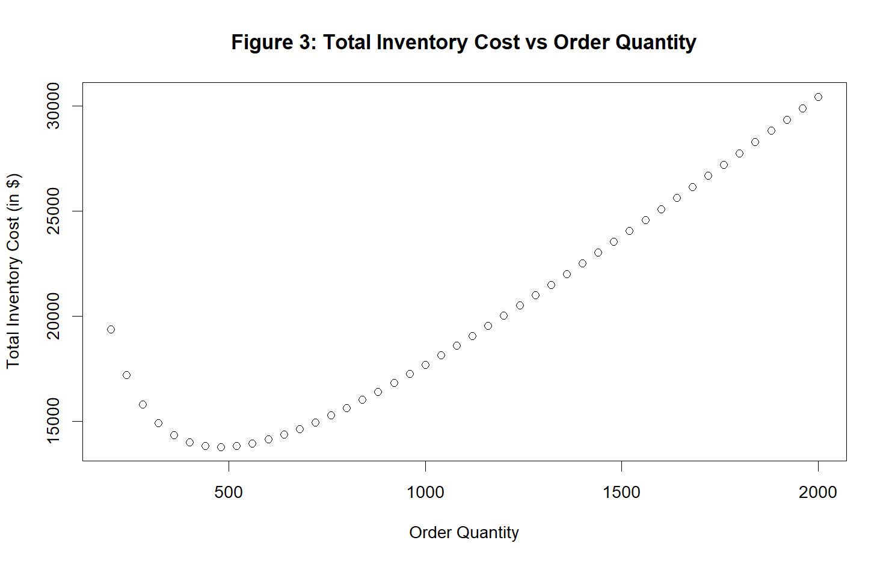

We can see that the order quantity value obtained from implementing the model in Excel spreadsheet and R programming is one and the same. This proves that the model has **consistent value irrespective of the implementation method** used.

**Function optimize() in R**

The function optimize looks the interval from lower to upper for a minimum or maximum of the function f which is to be optimized. This function is part of ‘**stats’** library in R. The logical argument ‘**maximum’** is used to define if the problem is minimization or maximization. Another argument ‘**tol’** is used to pass the desired accuracy.

A user-defined function **optimiseCostFun** is coded with the defined mathematical model, the threshold interval for the order quantity is defined as a (100,800) and the optimise() is used on the user-defined function.

|  |
| --- |
| > cost_optimization  $minimum  [1] 478.7135  $objective  [1] 13786.95 |

This function returns **two values** namely the minimum or maximum value and the objective of the optimization. In our case, the minimum order quantity value solved using optimise function ran on your model is **478.71 units with a minimum total cost involved being $13786.95.**

**Using Excel Solver**

Excel Solver is an optimization tool for determining the intended output by altering the assumptions in a model. It solves the problem by plugging in many values for the decision variable.

Table 3 illustrates the solution of our inventory management problem using the Excel solver. This is an optimization problem to find the minimum value of the total cost involved which is varied by the order quantity value. The **highlighted** are the values obtained from the excel solver.

*Table 3: Solving the optimization problem using Excel solver*

|  |  |  |
| --- | --- | --- |
| **Parameter** | **Value** | **Type of Parameter** |
| Annual Demand (in units) | 15000 | Uncontrollable Variable |
| Unit Cost | $80.00 | Parameter |
| Annual Carrying Cost Rate | 18% | Parameter |
| Order Cost | $220.00 | Parameter |
| Inventory level prompting an order Q | **239** | Decision Variable |
| Order Quantity 2Q | 478 |  |
| Number of times to order N | 31 | Decision Variable |
| Annual Ordering Cost = Order Cost * N | $6,903.77 |  |
| Annual Holding Cost = 2Q * ((Unit Cost * Carrying Cost Rate)/365) * (2Q/(Annual demand/365)) * (annual demand/2Q) | $6,883.20 |  |
| Total Cost = Ordering Cost + Holding Cost | **$13,786.97** | Objective (minimum) |

We can see that the **values obtained from the Excel solver and the values from the implemented model are the same.**

**What-If analysis using two-way tabulation in Excel spreadsheet**

A what-if analysis is a strategy for determining how changes in the assumptions that forecasts are founded on affect expected performance. What-if analysis compares several situations and their potential results based on changing circumstances.

In what-if analyses, by using two-way tables in Excel, the sensitivity of total cost to changes in the model parameters **order cost and unit price** are calculated. In this analysis the values of the unit prices are varied from **$70 to $90** in steps of $1. The values of the cost order is varied from **$210 to $230** in the steps of $1. Figures 5 and 6 illustrates the glimpse of few values and their impact on the total cost involved.

From this analysis we can conclude that, the changes in the value of any of the parameters or when both the parameters are changed. The cost involved for inventory management increases with the increase the unit price and the order price. The cross-tabulation shows the sensitivity of the of total cost changes with effect to the model parameters.

**SUMMARY OF RESULTS AND ANALYSIS**

The mathematical decision model created for the inventory management has calculated that when the **order** **quantity is 480** there occurs the **minimum total inventory cost** of **$13787** (annual cost). Using excel solver or optimize function in R, we can get a more approximate value for these quantities to the nearest 10s. From the formulated inventory management decision model, we can conclude that the total inventory cost (order cost and holding cost) can have a **minimum** **value of $13786.95** when the **order quantity** is set to **478.714** units which leads up to **31 orders** to be placed annually for the given product with a unit cost $80, order cost $200 and 18% of unit price as holding cost. The what-if analysis illustrates how the total inventory cost for the given product varies in respect to the order price and unit cost of the product. It is suggested to set the **order** **quantity is 479 for our scenario.**

**DECISION MODEL USING TRIANGULAR PROBABILITY DISTRIBUTION**

The problem parameters are kept constant as above and the annual demand is assumed to have a triangular probability distribution function with the following values:

*Table 4: Triangular distribution*

|  |  |
| --- | --- |
| **Metrics** | **Values** |
| Minimum (a) | 13000 |
| Peak (c) | 15000 |
| Maximum (b) | 17000 |
| K = (c-a)/(b-a) | 0.5 |
| M =(b-a) (c-a) | 8000000 |
| N =(b-a) (b-c) | 8000000 |

Random variables are generated using R programming. 1000 simulations are generated, and the triangular probability distribution is used to calculate the values of the minimum total cost for every single simulation. The cost estimation is coded as an user-defined function and the in-built R function **optimise()** is used calculate the minimum total cost for every incidence.

**Expected minimum total cost**

The expected minimum total inventory cost was calculated using the mean simulated values and it found to be **$13791.05**. The confidence level is set to 95% and the expected minimum total inventory cost has values from **$13767.39 and $13814.71**.

First, we perform the **Shapiro–Wilk normality test** (Calc W) on our simulated values. The Shapiro Wilk test is a formal normality test and uses only the right-tailed test. When performing the test, the W statistic is only positive and represents the difference between the estimated model and the observations. With W statistic, the p-value is calculated. When the p-value is greater than the alpha value of 0.05, then the data is normally distributed.

|  |
| --- |
| > shapiro.test(x1)  Shapiro-Wilk normality test  data: x1  W = 0.9917, p-value = 2.077e-05  > shapiro.test(x1)$p.value > 0.05  [1] FALSE |

The above code helps to check the normality of the stimulated minimum total inventory cost using the Shapiro–Wilk test for normality.We can see that the **p-value is very small** and it is not greater than alpha value. Hence, the **test concludes that the stimulated minimum total inventory doesn’t follow a normal distribution**. When the sample size is sufficiently large this test may detect even trivial departures from the null hypothesis. Thus, **additional investigation** of the effect size is undertaken. For this assignment, we shall use **two graphical methods** Histogram and QQ-Plot chart to test the normality of the data.

The figure 7 is the **histogram** of the minimum total inventory cost from the simulation. We can see that the graph is more likely to be a bell curve and we can say that they follows the **normal distribution**. The figure 8 is **the Q-Q plots** which is used to determine the type of distribution. The points on the Normal QQ plot indicate if the dataset is univariately normal. If both sets of quantiles came from the same distribution, the points should form a **relatively straight line**. It is evident from the figure 8 that distribution of minimum total inventory cost fits the **normal distribution**.

**Expected order quantity**

The expected order quantity is calculated from the mean simulated values, and it found to be **479** units. With the confidence level set to 95% and the expected order quantity value falls within the lower limit of **478** units and upper limit of **480** units.

First, we perform the **Shapiro–Wilk normality test** (Calc W) on our simulated values. The p-value is calculated and compared with the alpha value of 0.05.

|  |
| --- |
| > shapiro.test(x2)  Shapiro-Wilk normality test  data: x2  W = 0.99135, p-value = 1.321e-05  > shapiro.test(x2)$p.value > 0.05  [1] FALSE |

The above code helps to check the normality of the stimulated order quantity using the Shapiro–Wilk test for normality.We can see that the **p-value is very small** and it is not greater than alpha value. Hence, the **test concludes that the stimulated order quantity using** **doesn’t follow a normal distribution**. However, we perform **additional investigation** by using **two graphical methods** Histogram and QQ-Plot chart to test the normality of the data.

The figure 9 is the **histogram** of the order quantity from the simulation. We can see that the graph is more likely to be a bell curve and we can say that they follow the **normal distribution**. Figure 10 illustrates **the Q-Q plots** of stimulated order quantities. It is evident from the figure 10 that the **qqline** is **relatively straight** fitting in all the values. We can conclude that thedistribution of **order quantity fits the normal distribution**.

**Expected annual number of orders**

The expected number of total orders made in a year is calculated from the mean simulated values, and it found to be **31 orders**. With the confidence level set to 95% and the expected number of total orders remains as **31** (both upper and lower limit value is 31).

First, we perform the **Shapiro–Wilk normality test** (Calc W) on our simulated values. The p-value is calculated and compared with the alpha value of 0.05.

|  |
| --- |
| > shapiro.test(x3)  Shapiro-Wilk normality test  data: x2  W = 0.9917, p-value = 2.077e-05  > shapiro.test(x3)$p.value > 0.05  [1] FALSE |

The above code helps to check the normality of the stimulated number of total orders (annual) using the Shapiro–Wilk test for normality.We can see that the **p-value is very small** and it is not greater than alpha value. Hence, the **test concludes that the stimulated annual total number of orders doesn’t follow a normal distribution**. However, we perform **additional investigation** by using **two graphical methods** Histogram and QQ-Plot chart to test the normality of the data.

The figure 11 is the **histogram** of the annual number of orders placed by the company for the given product from the simulation. We can see that the graph is more likely to be a bell curve and we can say that they follow the **normal distribution**. Figure 12 illustrates **the Q-Q plots** of the stimulated values of annual number of orders placed. It is evident from the figure 12 that the **qqline** is **relatively straight** fitting in all the values. We can conclude that thedistribution of **annual number of orders placed fits the normal distribution**.

**SUMMARY OF RESULTS AND ANALYSIS**

With the assumption that the given product has a unit cost $80, order cost $200 and 18% of unit price as holding cost and the annual demand for the given product follows a triangular probability distribution with range of 13000 and 17000 units and a mode of 15000 units, **a simulation of 1000 occurrences of annual demand of units are generated**. From the stimulated values, **the expected minimum total inventory cost, the expected order quantity, and the expected annual number of orders** are examined by constructing a **95% confidence interval**. From the graphical methods of histogram and QQ-Plot graphs, we can conclude that **all these parameters are normally distributed**. We can conclude that triangular probability distribution is the best fit for our data model.

**CONCLUSION**

The objective to minimize the Total Inventory Cost by determining the optimized order quantity is achieved by developing a mathematical decision model for inventory management. It is found that the for the given problem statement, the total inventory cost (order cost and holding cost) can have a **minimum** **value of $13787** when the **order quantity** is set to **479** units which leads up to **31 orders** to be placed annually. It is evident that this value remains same when the model is implemented using Excel, Excel solver, R and optimise() in R. Thus, we can conclude that **the solution for the problem remains same irrespective of the implementation method.**

The annual demand is also a crucial parament in the inventory management model. To test the impact of this parameter, we assume the annual demand of units for the given product follows triangular distribution and perform **simulations for 1000 times**. Values for the expected minimum total cost, the expected order quantity, and the expected annual number of orders are calculated for each stimulation. The values of all these three parameters are found to be **normally distributed**. Thus, we can concludethat **the triangular probability distribution best fits our decision model** for calculating expected minimum total cost and the expected order quantity when the annual demand for products varies.

**REFERENCES**

Evans, J. R. (2013). Statistics, Data Analysis, and Decision Modeling (5th Ed). Pearson

Shapiro, S. S., & Wilk, M. B. (1965). An analysis of variance test for normality (complete samples). Biometrika, 52(3–4), 591–611. <https://doi.org/10.1093/biomet/52.3-4.591>

**APPENDIX**

* ALY6050_MOD4Project_VaithilingamPalanimuruganV.R
* ALY6050_MOD4Project_VaithilingamPalanimuruganV.xlsx